**Performance graphs**

**MPI:**

**1. For 2 node cluster:**

**In all graphs Data varies from 10K to 1000 K.**

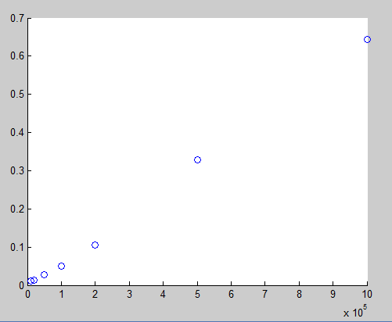

So a general pattern will be

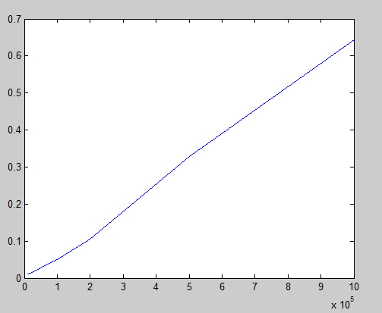

2 NODE MPI CLUSTER PERFORMANCE

2. **For 3 Node cluster**

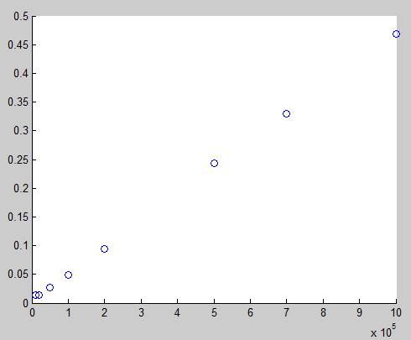

**3 NODE CLUSTER PERFORMANCE**

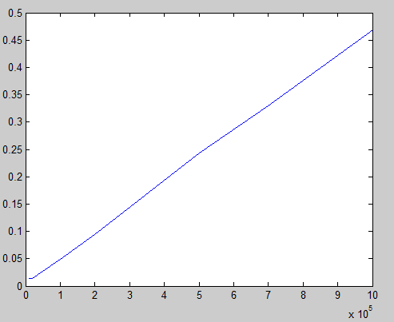

**3 NODE CLUSTER GENERAL PERFORMANCE**

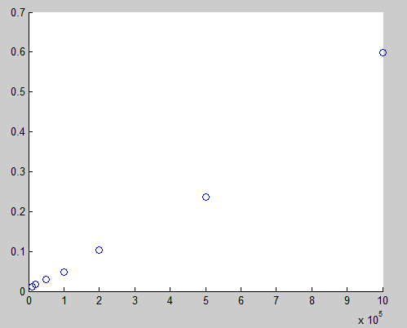

**4 NODE CLUSTER PERFORMANCES**

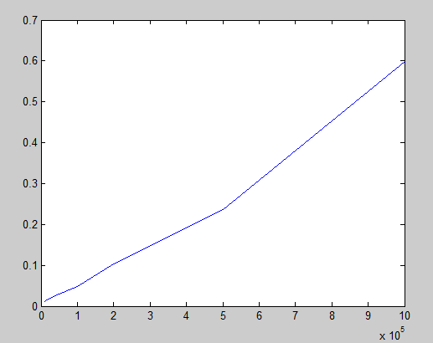

**4 NODE CLUSTER GENERAL PERFORAMNCE**

**2. JOIN QUERY PERFORMANCE CURVES**

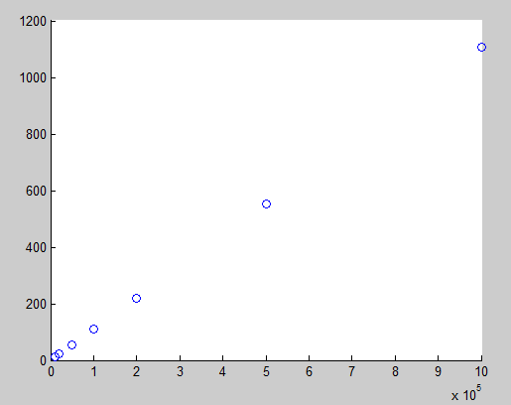

**2 NODE PERFORMANCE**

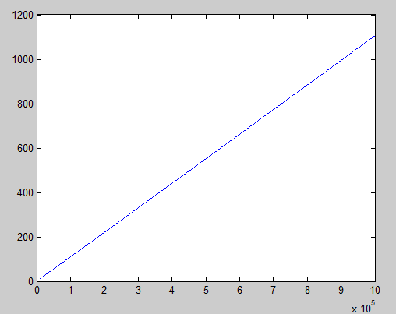

**2 NODE GENERAL PERFORMANCE**

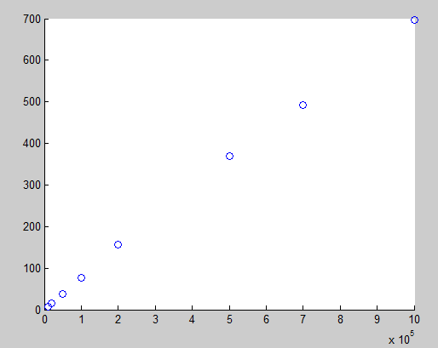

**3 NODE PERFORMANCE**

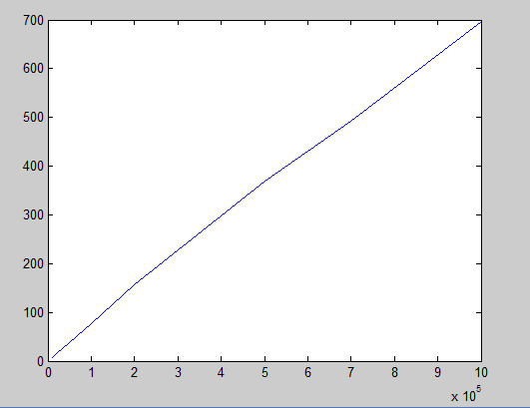

**3 NODE GENERAL PERFORMANCE**

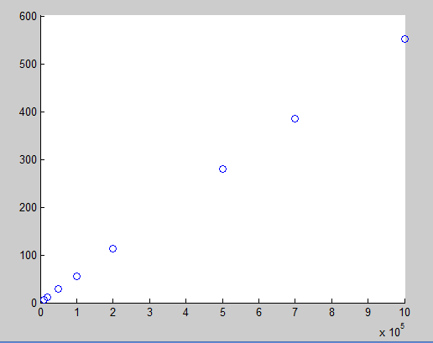

**4 NODE PERFORMANCE**

2.**FOR HADOOP:**

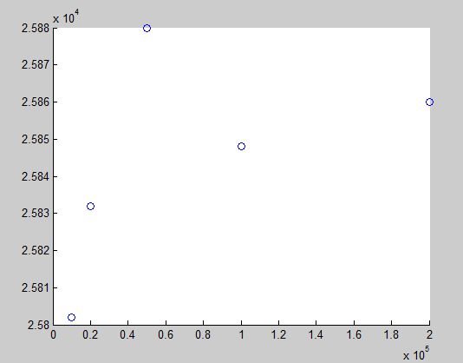

**8 NODE HADOOP CLUSTER**

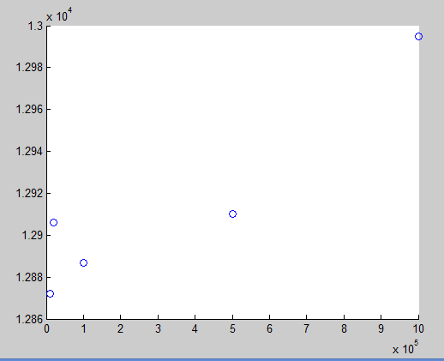

**3 NODE HADOOP CLUSTER PERFORMANCE**

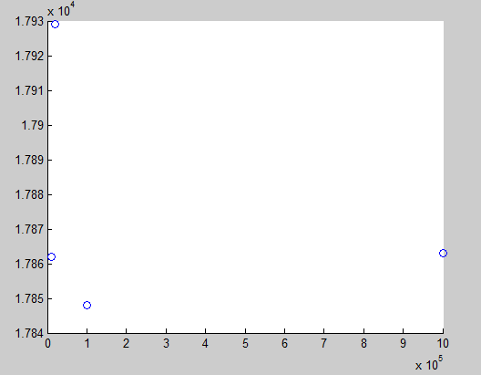

**2 NODE HADOOP CLUSTER PERFORMANCE**

**Performance measured by varying number of node**

Number of nodes are 2,3 and 4

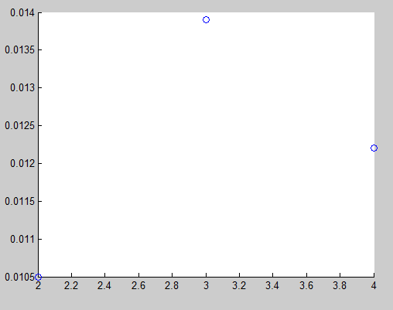

**FILE SIZE 10K**

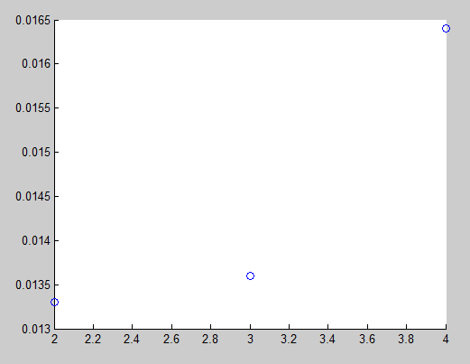

**File size 20K**

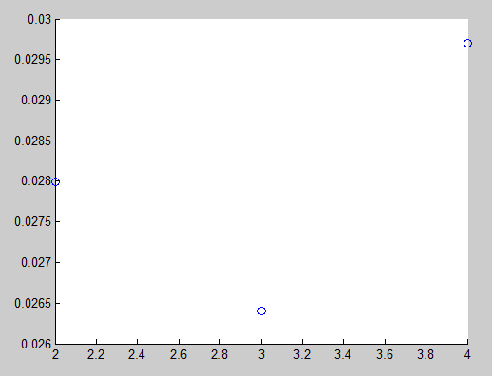

**File size 50k**

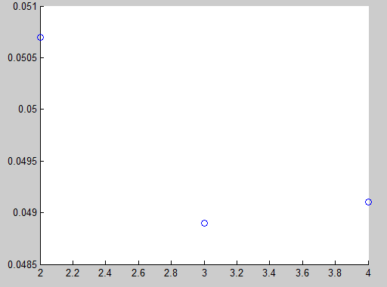

**File size 100K**

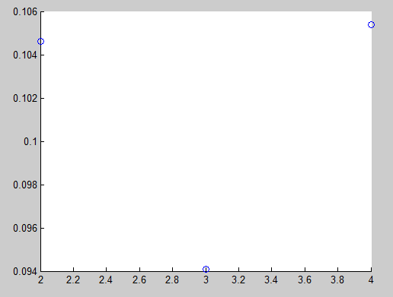

**File size 200k**

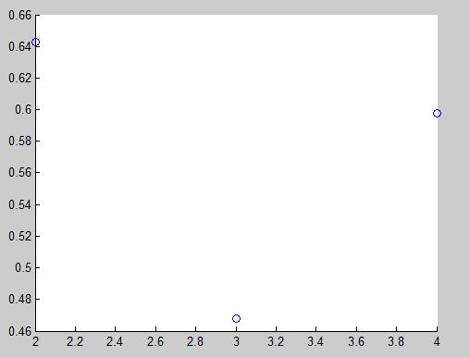

**File size 1000K**